**Lab task no:5**

**Talha rafique**

**471701**

**1:**

#include <iostream> 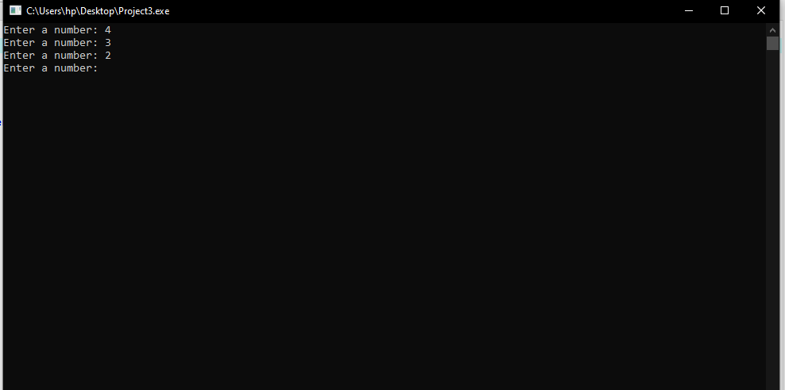

using namespace std;

int main() {

int x;

do {

cout << "Enter a number: ";

cin >> x;

} while (x > 0);

return 0;

}

**2:**

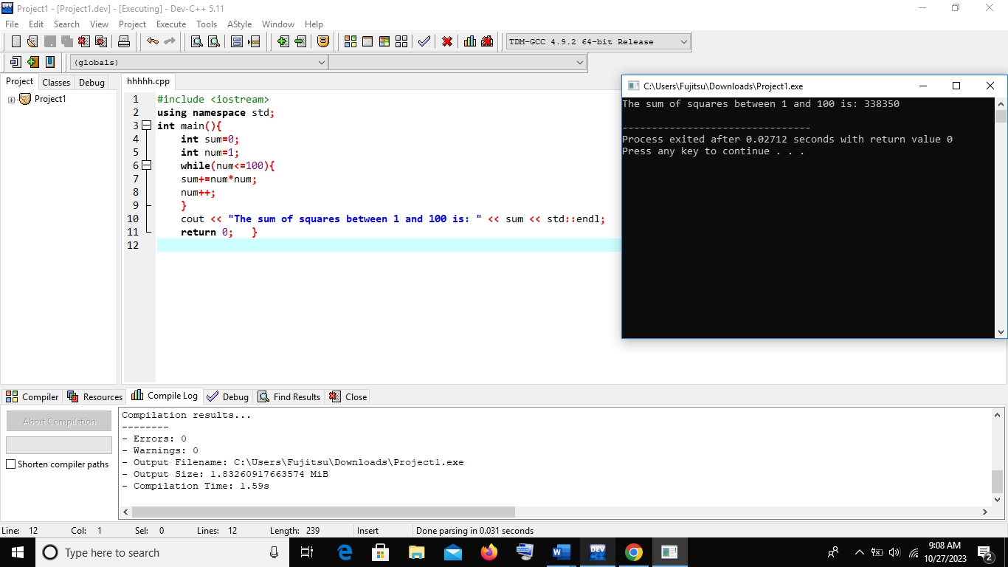

**3:**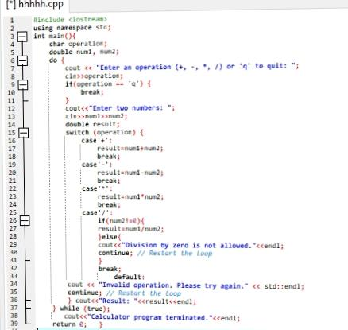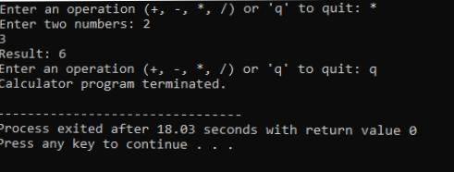

**4:**

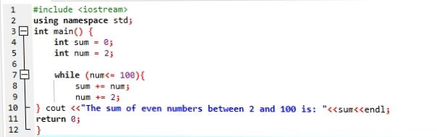

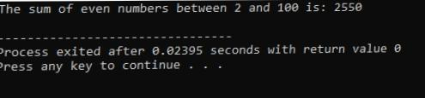

**5:**